**ENERGY MANAGEMENT SYSTEM APP**

Energy management system is software automation system that collects energy measurement data from the field and making it available to users through graphics, online monitoring tools and energy quality analyzers enabling the management of energy resources.

Energy analyses of systems are normally associated with costs and in some instances, the analysis is used to compare performances of alternative packages.

Energy Management Software collects historic and/or real-time interval data, with intervals varying from quarterly billing statements to minute-by-minute smart meter readings.

**Importance of EMS**

1. Analyzes and processes energy data
2. Energy monitoring – This increases productivity hence reducing operational costs
3. Realizing faults easily – This helps to take timely measures to limit extra faults
4. Maintaining energy balance – This saves energy because it understands real time energy demand and consumption

Determining how much electricity appliances and other electronics use can help in understanding how much money is spent to use them.

**Ways of estimating how much electricity appliances use:**

1. Reviewing the Energy Guide label. The label provides an estimate of the average energy consumption and cost to operate the specific model of the appliance you are using.
2. Using an electricity usage monitor to get readings of how much electricity an appliance is using
3. Calculating annual energy consumption and costs using the formulas
4. Installing a whole house energy monitoring system.

Our energy management app allows you to estimate your annual energy use and cost to operate specific appliances and other electrical devices. The wattage values provided are the ratings of the devices; actual wattage of products varies depending on product age and features.

**SWOT analysis of existing Energy Management Systems.**

|  |  |  |  |  |
| --- | --- | --- | --- | --- |
| **EMS** | **Strength** | **Weakness** | **Opportunities** | **Threats** |
| Entronix | Highly efficient in energy consumption reporting | It is very costly with each feature costing around $100 | Saving time in reporting and documentation of energy records | Rising overall energy management cost |
| Emerald EMS | Has real time meter data acquisition enabled through smart metering | The app cannot be customized for to accommodate other features | Competent fault detection | Region-specificity |
| Snapmeter | Factors in environmental conservation measures in energy management | It does not have all the features that we need | Consideration of robust renewable energy sources | Time consuming energy management operations. |
| Energy Elephant | Cross- platform  Instant generation of reports, save lots of time by reducing manual works. | Cost implication. Pricing starts from €660/month | Good documentation and allowance to train user on app usage | There is a limitation in customization of dashboard |
| DEXMA Energy Intelligence | incorporate all aspects of energy management | Only web-based solution is available | Has a free trial for self-training on app usage | Custom report builder is difficult to use and limited |

**Our Energy Management System App.**

These are the steps for finding the annual energy consumption of an appliance, as well as the cost to operate it using our energy management app:

1. Input the estimated number of hours per day an appliance runs.
2. Input the wattage of the product.
3. The app finds the daily energy consumption using the following formula: (Wattage × Hours Used Per Day) ÷ 1000 = Daily Kilowatt-hour (kWh) consumption
4. The app finds the annual energy consumption using the following formula: Daily kWh consumption × number of days used per year = annual energy consumption
5. The app finds the annual cost to run the appliance using the following formula: Annual energy consumption × utility rate per kWh = annual cost to run appliance
6. The app then analyses the data and generates reports
7. The app can provide notifications if there is abnormal energy usage
8. The app can also recommend some energy saving tips.

For now, will input this data manually. For it to be an automated process, or for more accurate data as well as the ability to measure the energy use of 240-volt appliances), a building should be installed with an energy monitoring system. The features of these systems vary, and the cost and complexity depends on the number of circuits you want to monitor, the level of detail of the data, and the features available. The monitors are often installed directly in the main breaker panel of the building, and some may require an electrician to install. Some monitors must be connected with the building’s wireless network and data is viewed on a computer or smartphone, while others come with a dedicated display.

**Advantages of our app over other apps out there**

1. Free to use
2. Can be customized according to our needs and desired features
3. Monitors every appliance in the building and generates a report for each
4. It can generate daily, weekly, monthly and annual reports (See appendix *1.1*)
5. It can offer recommendation on energy saving tips (See appendix *1.2*)
6. It can notify you if there is abnormal power usage by sending a notification in the notifications section of the web-based application (See appendix *1.3*)

NB: The first version of the app will be web based, later we can develop an android/IOS version.

**EMS APP DETAILS**

**BACKEND**

We will build an API for our backend using NodeJs framework. An API is a software intermediary that allows two applications to talk to each other. This means that we can consume/integrate our API with other frontend technologies such as web, android, IOS, desktop apps etc.

Summary:

Programing language: JavaScript

Framework: NodeJs

Database: Mongo DB

Github link: https://github.com/dennocapi/energy_management_app_backend.git

**Database: MongoDb**

MongoDb is a source-available cross-platform document-oriented database program. Classified as a NoSQL database program, MongoDB uses JSON-like documents with optional schemas.

Why MongoDb:

1. Flexible document schemas
2. Code-native data access
3. Change-friendly design
4. Powerful querying and analytics
5. Easy horizontal scale-out

The figure below is our mongodb database structure. We have named collection as EMS (Energy Management Software).

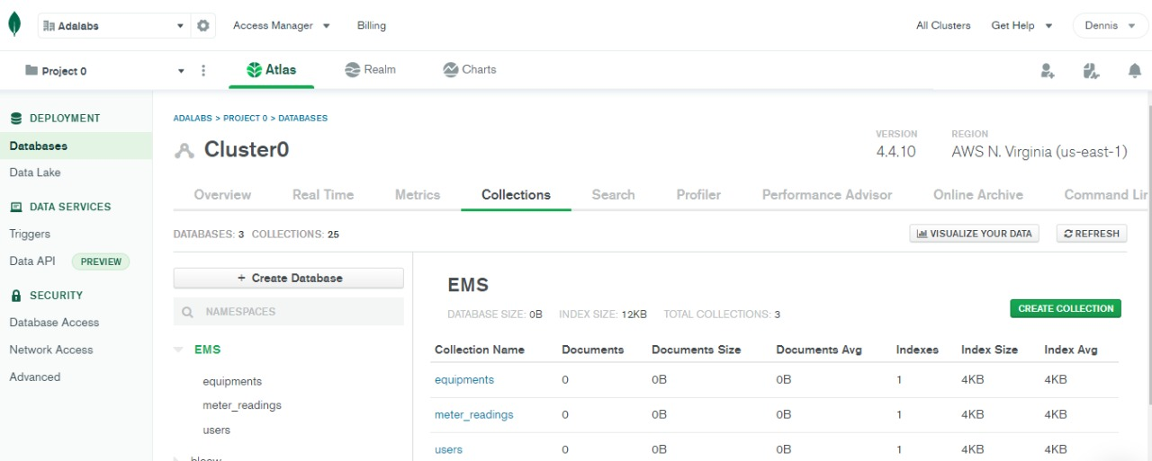

**Postman**

Postman is an API platform for building and using APIs. Postman simplifies each step of the API lifecycle and streamlines collaboration so you can create better APIs—faster.

We will use postman to simulate data sent from the backend before building our frontend.

The figure below is an image of our EMS app collection in postman.

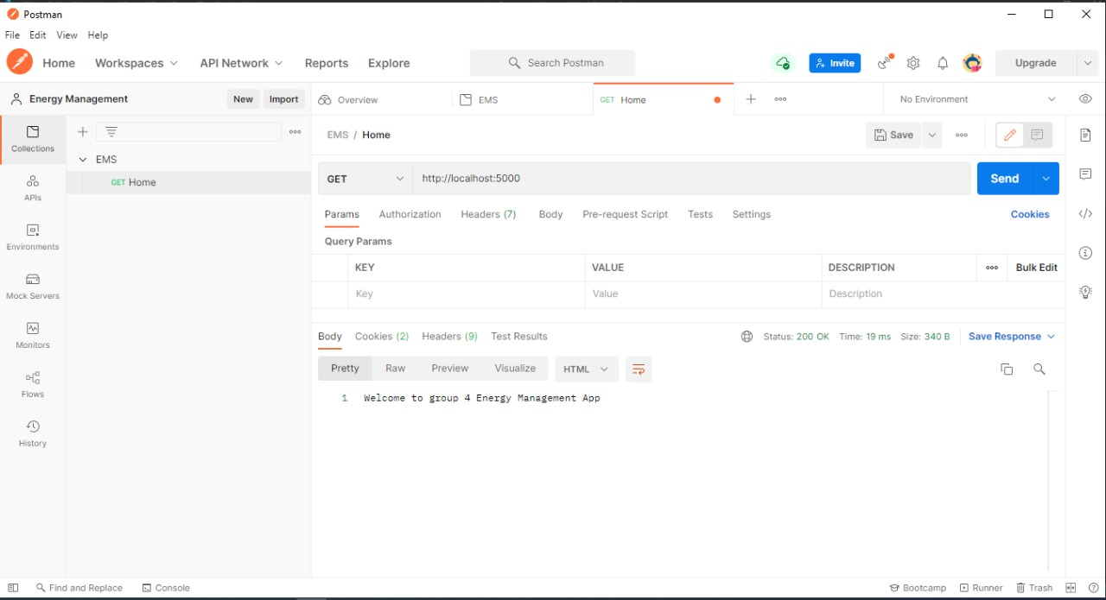

**Github**

Github is a provider of Internet hosting for software development and version control using Git. It offers the distributed version control and source code management (SCM) functionality of Git, plus its own features. It provides access control and several collaboration features such as bug tracking, feature requests, task management, continuous integration and wikis for every project.

We will back up our code in github. We will make the link public so that others can be able to review our code and advise us on where to make changes.

The figure below is an image of our github page.

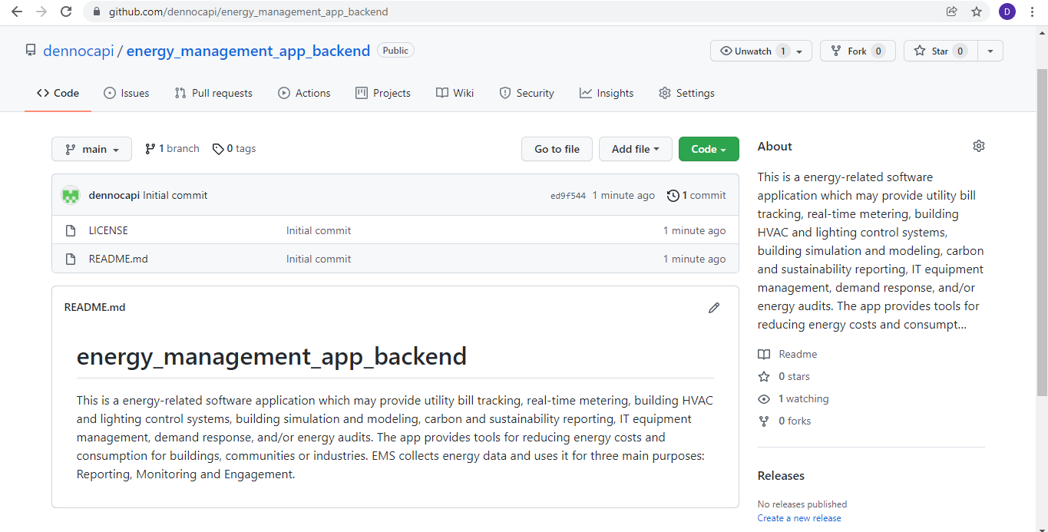

**What we have done so far:**

1. App design – This involved:

* Understanding what our app will do
* The type of data we will be collecting
* How we will store the data
* Type of database to use
* How to present the data after analysis to the user

1. Authentication – To use our app, one should be authorized e.g. to enter data or view data of a certain company.

This step involved:

* Registering a company/institution/building
* Login
* Logout

**What we will program the app to do next:**

* A user to be able to register equipment data e.g. rating
* A user to be able to enter Bill data

**Code sample:**

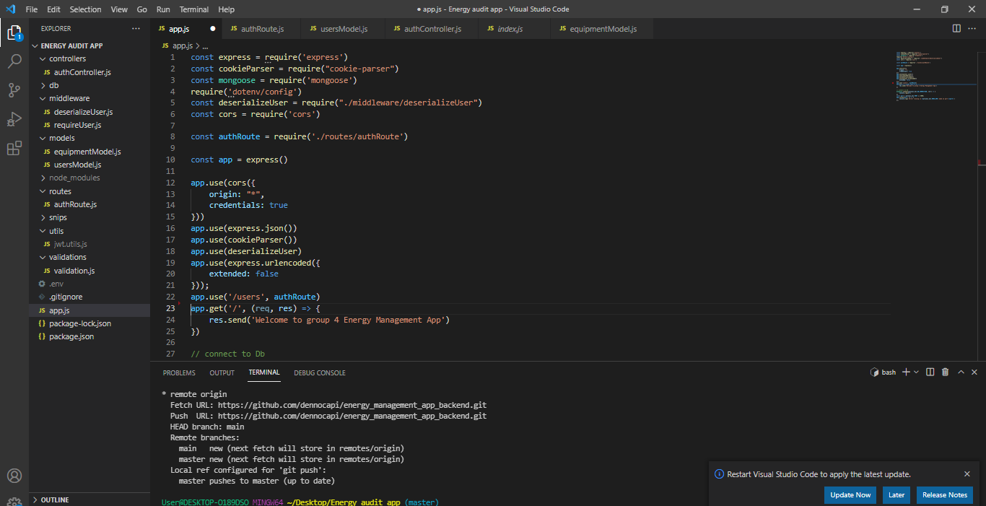

**APPENDIX**

The daily, weekly, monthly and annual energy consumption reports will be generated in the form of pdfs and graphs.

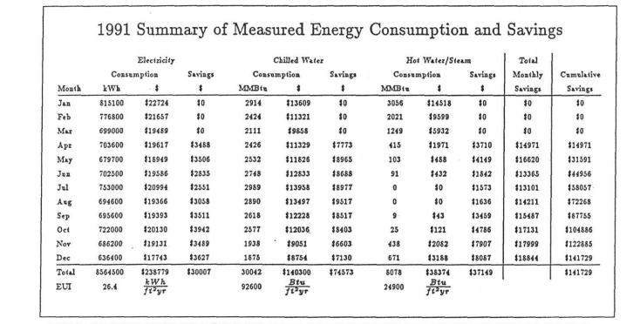

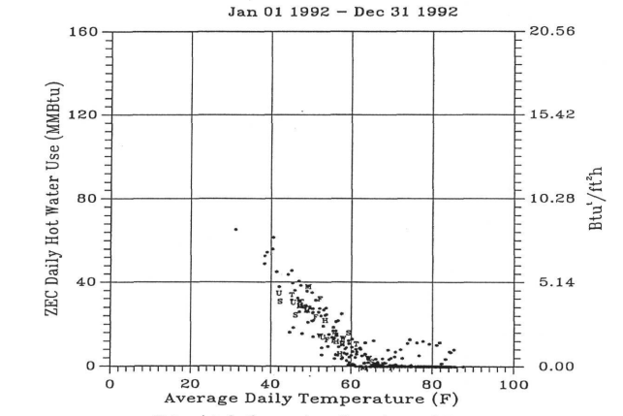

1.1: Daily, weekly, monthly and annual reports.

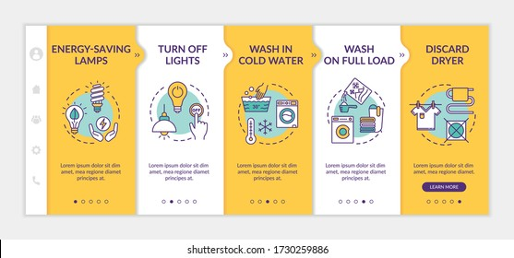

1.2: Energy-saving tips.

There is abnormal power usage with sockets at the facility

1.3: Abnormal power usage notifications